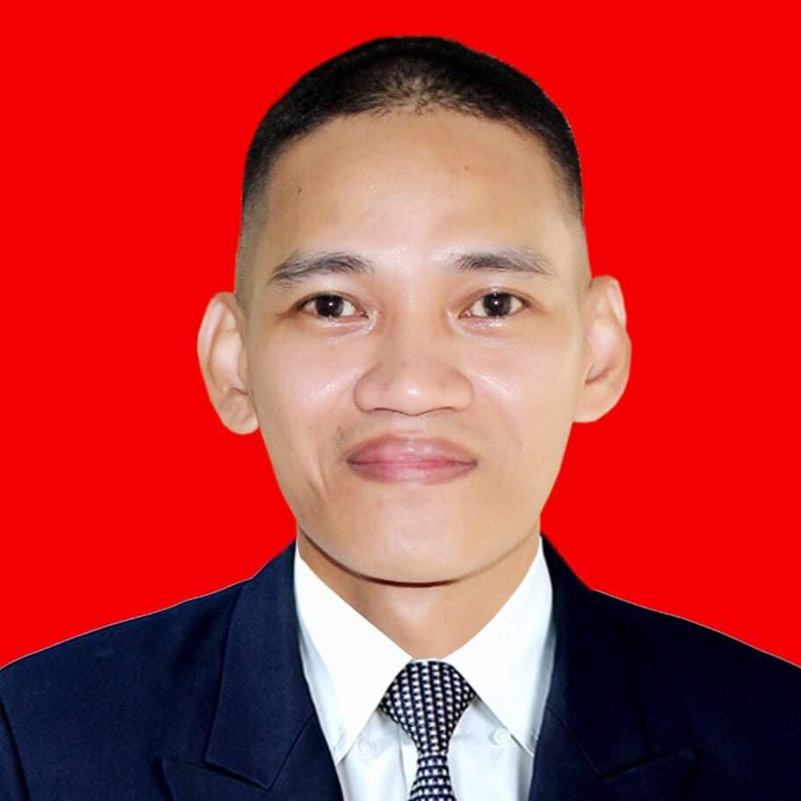
ANDREW R. CASTILLO ____________________________________________________________________________

550 P. Burgos Street, Mandaluyong City, Philippines
Contact No. : (0961)3828082● Mobile:(0915)7555961

drewdurst18@yahoo.com

Profile

Multi Lingual Customer Service Professional with cross-functional expertise in administrative

tasks, telesales and helpdesk technical support. More than 10 years of expertise in the field

of customer service – corporate (SSC) and BPO/call center industry.

Proven history of working and assisting local and Malaysian/Indonesian clients via phone and email.

Computer literate in multiple operating systems and software applications. Excellent interpersonal

and analytical skills and goal oriented and certification in SAP application

Experiences
November 2021-April 2023 Capgemini Philippines Corp.
Credit and Collection Senior Analyst
- Reach out to customer on delinquent accounts via phone or email in an attempt to collect payment.
- Monitor an assigned book of business and work to proactively address process and billing issues with customers to result in payment
- Process one call one collect from B2B Clients in Indonesia and malaysia
- Liaises with key account managers and sales account managers regarding collections deadlines.
- Prepares monthly and quarterly balance justifications and documentation.
- Prepares customized weekly reports.

May 2020-June 2022 Conduent Business Services Philippines, Inc
Accounting Services Analyst II & Procurement
- Tracks and reports business-critical project and people metrics for client operations.
- Finalizes the intercompany reconciliation process.
- Liaises with AP and the business.
- Prepares monthly and quarterly balance justifications and documentation.
- Prepares customized reports and dashboards.
- Keeps updated data readily available for presentations or reporting.
- Performs other duties as assigned. h) Complies with all policies and standards.
- All other duties as assigned

June 2019-May 30 2021, SC Johnsons Philippines SSC Customer fulfillment (FOT)

Essential Duties and Responsibilities:
- Proactive order management and anticipating and solving issues relating to customer orders using SAP Based Application.
- Liaise with customer to coordinate delivery dates based on stock availability / prioritize destinations (during reception windows).
- Day to day liaison between Logistics Service Providers (LSP) and local country (Sales, Logistics & Finance Departments).
- Escalation of stock allocation and customer service issues to Team Leader.
- Management of customer inquiry resolution through development and implementation of action plans to eliminate the source problem.
- Identifies and implements process improvements and identifies efficiencies and best practices
- Conducts trade visits with sales representatives and visits local country as representative of Shared Services Center (SSC), if required.
- Collaborates with E-commerce department to solve systems issues.
- Develops and maintains customer service performance reporting systems to assist local country in efficient management of its business.

October 2, 2017- February 2018 Bahasa Malaysia/Indonesia Inside Sales Representative
SITA Aero
- Source new sales opportunities through inbound lead follow-up and outbound cold calls and emails.
- Understand customer needs and requirements.
- Route qualified opportunities to the appropriate sales executives for further development and closure.
- Research accounts, identify key players and generate interest.
- Maintain and expand your database of prospects within your assigned territory.
- Team with channel partners to build pipeline and close deals.
- Perform effective online demos to prospects.

August 2014 – July 2017 Bahasa Malaysia/ Indonesia Multilingual Reservations Specialist
IHG (Intercontinental Hotels Group)

- Provides information to Indonesian and Malaysian guest or visitor
- Provides basic concierge service
- Process all payments while adhering to all cashiering procedures
- Documents and confirms reservations and cancellations
- Block rooms and pre-register designated - guest and prepare key packets
- Communicates pertinent guest information to designated departments i.e. special -request, and organizing amenities for delivery
- Resolves discrepancies on room status
- Reports with Housekeeping
- Generates, prints and distributes daily and weekly reports
- Inputs all guests’ request and departmental -request promptly and accurately into the HotSos response system
- Coordinates and assigns dispatching work orders to the appropriate department
- Inputs all guests wake up calls as requested
- Handles internal and external calls
- Performs other duties, task and special projects as assigned

June 2013 – November 2013 Bahasa Malaysia/Indonesia
Multilingual ITHelpdesk/Resource Techincian
Aegis People Support/ GSK Glaxo Smith Kline

Provides maintenance of the computer desktop environment by analyzing
requirements, resolving problems, installing hardware and software solutions,
and supporting the internal IT Helpdesk.
Responsible for administration and internal support of the Company’s
PCs, printers, servers, and related equipment.
Tasks include end user support license tracking and performing PC maintenance, upgrades and configurations.
Responsibilities:
- Provide helpdesk support and resolve problems to the end users satisfaction via Live chat, email and telephone.
- Monitor and respond quickly and effectively to requests received through the IT helpdesk
- Monitor Service Desk for tickets assigned to the queue and process first in first out based on priority
- Modify configurations, utilities, software default settings, etc. for the local workstations, SAP, Windows XP, Widows 7, Lotus Notes, Team viewer, Outlook, OCS, Antivirus and other softwares.

- Utilize and maintain the helpdesk tracking software
- Document internal procedures
- Assist with on boarding of new users
- Install, test and configure new workstations, peripheral equipment and software
- Maintain inventory of all equipment, software and software licenses
- Report issues to the Service Desk for escalation
- Manage PC setup and deployment for new employees using standard hardware, images and software
- Assign users and computers to proper groups in Active Directory
- Perform timely workstation hardware and software upgrades as required.

March 2011- December 2012 Bahasa Malaysia Multilingual/Indonesia
IT Helpdesk Support Technician/Subject Matter Expert
Stefanini TechTeam/ Galileo by Travelport

- Provides process updates to the team and point of escalation for complicated issues.
- Provides specific product and software support to Galileo end-user and potential end-users, hence pre-sales and Marketing support for Malaysia, Singapore and Philippines using Bahasa, English and Filipino languages. While providing support, the project SLA's are to be adhered to while applying project and client specific procedures.
- Analyzing support requests sent by the customers by calls, mail, web submit or any other means of communication as a consequence of a Client's request o Tech Team decision for change
- Provides restorative or maintenance actions to resolve end-user problems. Respond to end-users problems based on standard procedures. Ensures systems are configure appropriately.
- Provides training process updates to team and new hires and refreshment training for Market Specific. ( Malaysia, Singapore and Philippines.) If required provide GCC trend analysis report.
- Conducts call monitoring for 1st level Helpdesk Agents.
- Act as SPOC for technical Issues experienced by the team members and contribute to the reduction of escalations.

January 2010– February 2011 Bahasa Malaysia/Indonesia Multilingual IT Support Specialist
Sutherland Global Services / Microsoft Store ( Project Based )

- Provides First-line (Tier1) Technical Support over the telephone or online by e-mail and sufficiently Serves Microsoft customers and Microsoft product users. Determines the customer’s issue by analyzing the symptoms and figures out the underlying problems before escalating the issue to a higher level TSR.
- Provides first contact resolution for Microsoft customers.
- Answers general inquiry about the Microsoft Store website.
- Verifying proper hardware and software set up.
- Processing Orders and Pre-sales for customer over the phone.
- Appropriately escalate issues to the designated departments.
- Provides step by step procedure on the downloading process.
- Uninstalling/Reinstalling basic software applications.
- Resolving customer’s username and password and product key issues

May - October 2009 Bahasa Bilingual Support Specialist
ALLSECTECHNOLOGIES INC, PHILIPPINES

- Processing appointments for visa applicants in the Austrian embassy from Indonesia, Shanghai, Thailand, Philippines and USA.
- Provides first contact resolution of customer support for the client's concern and general inquiries.

Jan 2007 – February 2009 Bahasa Malaysia/ Indonesia Multilingual IT Support Specialist
Vision-X / Western Union Financial Services Phils., Inc.

- Handles request that facilitates the money transfer process from Customers/Agents
Across Asia pacific supporting Bahasa Malaysia/Indonesia/Tagalog Languages through phone or email.

- Provides first-level support for customer complains over the phone or by email.
- Provides Technical Support for multiple Agents/Sub- agents on their software and system issues.
- Resetting password and setting up accounts for new Agents and Sub-agents
- Analyzing and making decisions on fraudulent and suspicious transactions that
has compliance and security issues.
- Documents and escalates issues to relevant departments.
- Promotes Western Union products and services.

Freelance Jobs:

2009 -Present Freelance Vocal coach/Voice Over/Dubbing/Talent for Bahasa Malaysia/Indonesia
Red Glass Language Resources

- Talent for Bahasa Malaysia/Indonesia TV Commercials
- Vocal Coach for Bahasa Malaysia/Indonesia Voice Dubbing/TV Commercials
- Voice Over/Voice Bahasa Malaysia/Indonesia Dubbing for other Projects
- Translator for Bahasa Malaysia/Indonesia scripts to English and vice versa

January 2010 - Present Freelance Bilingual representative
INFORM SOFTWARE
- Promotes updates about new Cisco products to the IT Managers in Indonesia.
- Schedules face to face sales interview with potential clients.
- Lead generation, Marketing research and Translation’
- Invoicing and other related HR task.

Seminars & Trainings Attended
November 2006 Call Center Training Program, Informatics Institute Philippines

Education
2005 Mechanical Engineering - Vocational Diploma / Short Course Certificate
Don Bosco Technical College

Personal Particulars

Date of Birth: January 19, 1982
Marital Status : Married

